Jake Hall – Ian Donovan

**What has been Accomplished so far:**

So far, we have fully implemented a general login screen. This page splits off into a twitter login and Facebook login html page. The Facebook page allows a user to login through Facebook and, when connected, redirects to the home page. The twitter page will soon do this as well. There is a basic HTML page set up for the home page of the app, but it will be expanded on.

**What we are behind on:**

Logging in with Twitter. Unfortunately, twitter is proving to be harder to implement a login for than expected it would be. Currently Ian is working his way through the issue and we are expecting it to be working within the next day or two. With this comes the need to seek out dedicated hosting for the site for us to properly implement all server side programming.

**What we are ahead on:**

Currently we are slightly ahead of our schedule on the front-end design, the general login page html implementation went much smoother than expected and is already completed.

**What’s next:**

Our next step will be working on the home page. The color scheme will need to be changed in the CSS to match the login screens. In addition, we plan to swap out the text on the side bar with icons. The step after that will be creating the social media specific html page (see the Twitter Home Screen Mockup below). We intend to achieve this through either jQuery’s DOM modification tools and have already done some experimentation on getting platform-based templating going.

**Photos:**

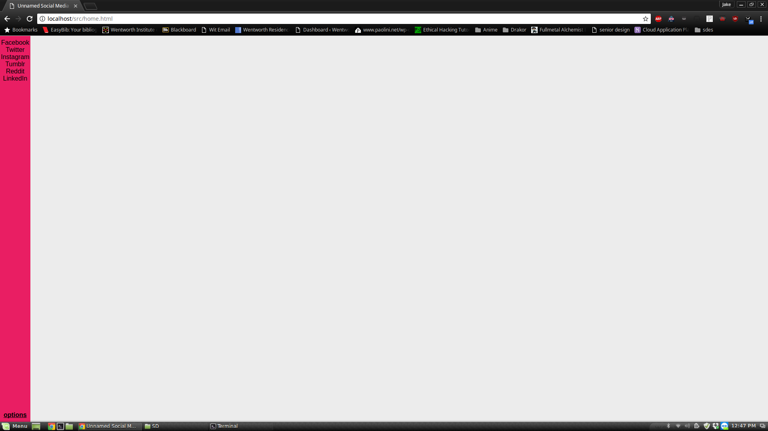

*The Home Page (a Work in Progress)*

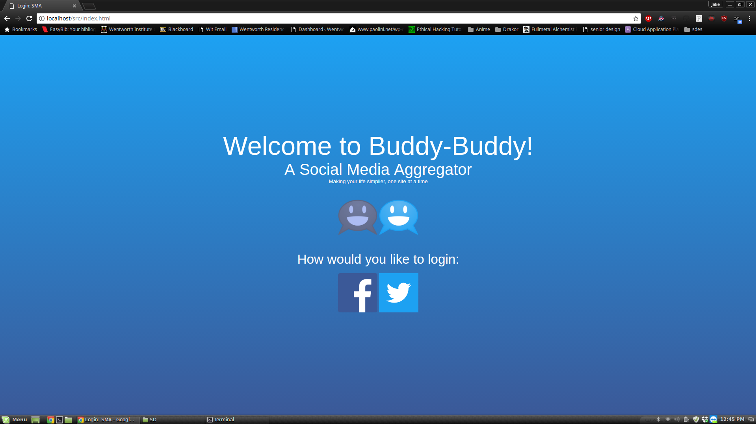

*The General Login Screen*

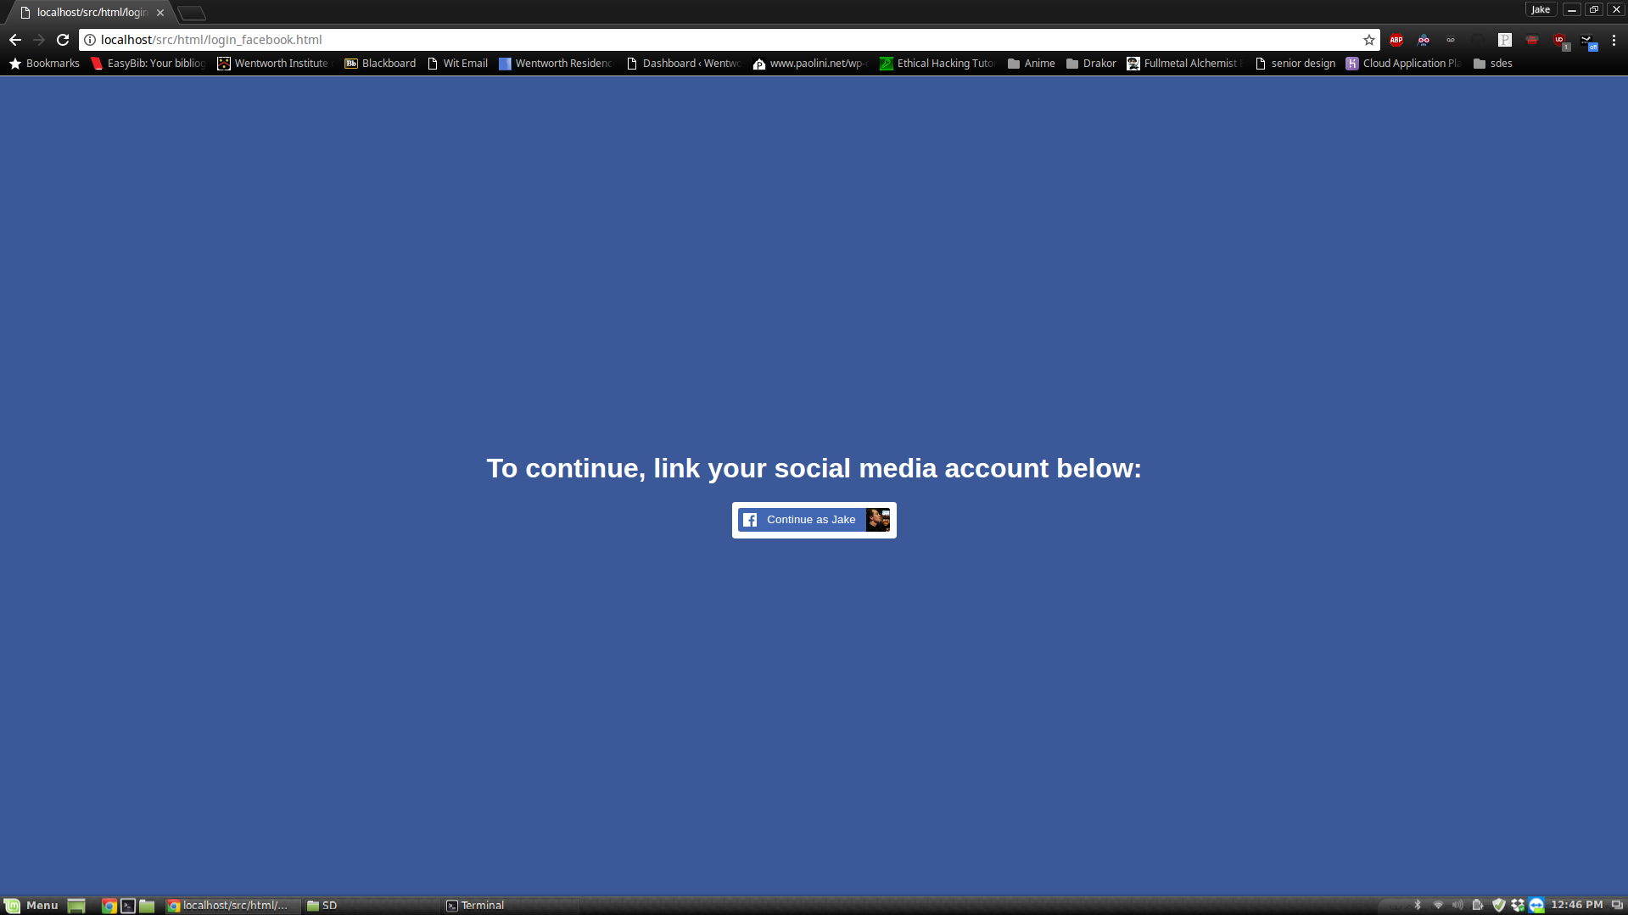

*The Facebook Specific Login Page*

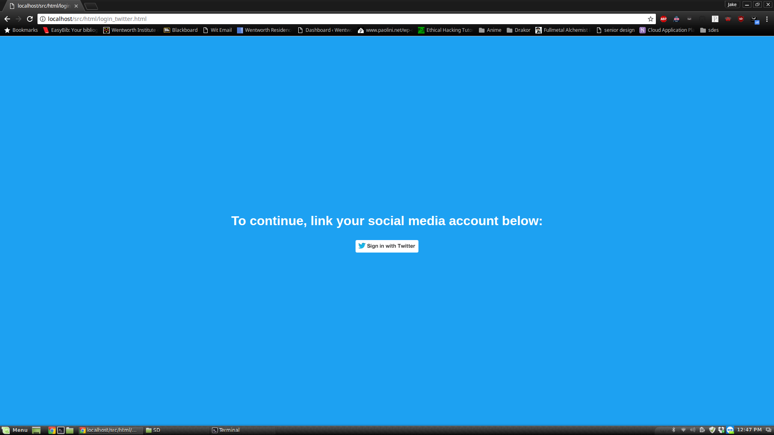

*The Twitter Specific Login Page*

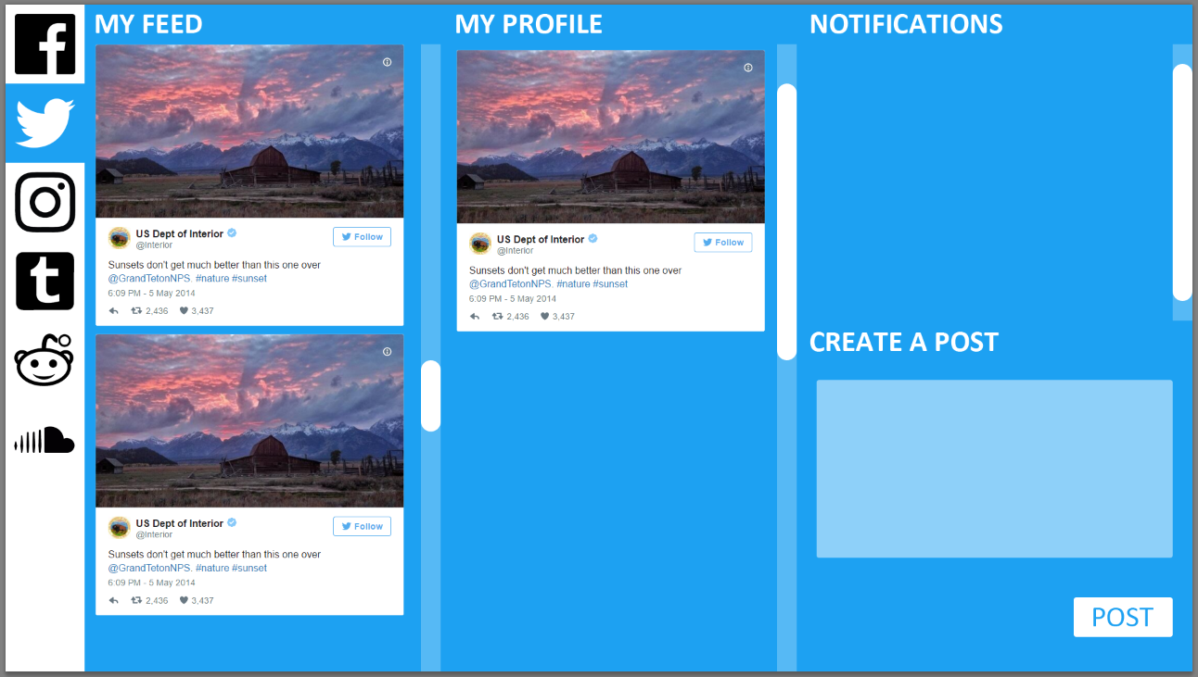

*Twitter Home Screen Mockup*